Stand Up, America & The Wise Virgins
May 9, 2016

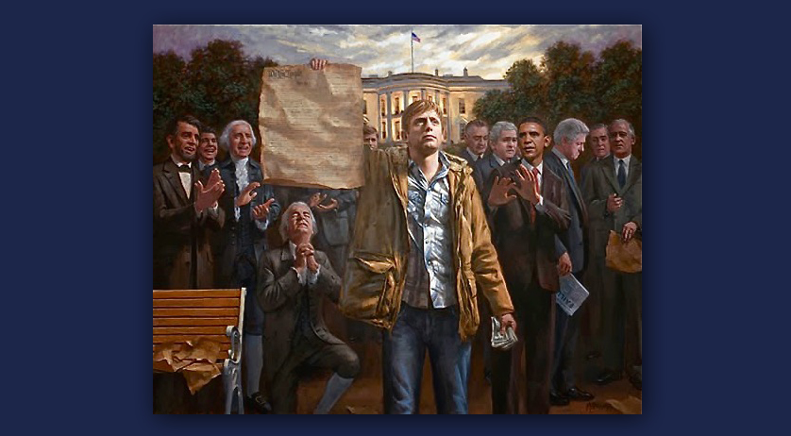
May the courage and stamina of the Lord uphold us all, Heartdwellers.

Well, after my prayer time, the Lord went right into the message.

He said, “As things begin to heat up in your country I will be calling more and more souls into prayer. Yes, I have given some pleasant and hopeful things to do, but intercession right now is increasing in need. Those who oppose Trump have planned several assassination attempts but I will foil them all if only you will pray and raise a standard of protection around him and his family. I do intend for him to take office, that is My intention. But for this to happen you must all pray him in with fasts and offerings.

"His family, as well, must be protected as many curses have been leveled against them. I am calling all Christian leaders and ministers to strip these curses off daily. They cannot succeed if you all are doing your jobs. His safety is reliant upon your prayers, all of you. Not just those who tune into this channel, but all of you around this world have a part in bringing a reprieve to America.

"As souls continue to be gathered into the Kingdom, I continue to hold back the wrath from moment to moment. Do not grow bitter like those of the world who say, 'Where is the hope of His coming?' These thoughts are of Satan and meant to undermine your faith. If you give them air-play and go into agreement with them, your faith will be compromised. Rather stand strong and tall with Me as I gather in those that remain and remember the parable of the virgins. They all fell asleep, but only the wise virgins had flasks of oil with them. Do you see the wisdom and warning of this?

"The virgins with the flasks were anticipating a possible delay and they prepared for it. The virgins with oil only in their lamps were impatient and expecting Me at any moment. They were tired and anxious to go, so they supposed I would not be delayed. So, they did not prepare adequately, keeping extra oil. They assumed I would come quickly.

"Some of you are now among that group. Turn around, dear ones, turn around. You cannot afford to grow weary in well-doing. You cannot push Me or accelerate My coming. These signs of impatience are presumption on your part and not a good place for you to be. Your lamps are running out of oil and you’ve not another flask to fill it with. Do you see yourselves in My mirror? The other virgins who are wise and waiting provided plenty of oil because they knew My Heart. They knew I would delay for the one out of 99 sheep that went astray or for those who did not yet know Me. Did I not speak to you about this in the parable of the virgins? I explained to you there that there would be a delay. I did that to prepare you, that you would be patient and expecting Me - but ready at any time, even if there were a delay.

"The wise virgins provided oil for their lamps because they knew My Heart, which is not to rush in and get you, but pull in as many as I can before it is too late. So you see, your lamps are running very low right now and you are at risk.

"Strengthen what remains, support Me in My mission of salvation, and do what’s been asked of you. If you would pursue something that gives you a bit of joy, the pain of our separation would not be so very painful. What you do now in these last days has great potential for the lost after you are taken.

"Make your gifts and your time count. Every second you live, every second given you in this life will be accounted for, whether you used it wisely or wasted it. Everything you undertake to gather in souls, to bring Me to them, to instruct them when you are gone, all of these endeavors will be richly rewarded because My words do not return to Me void.

"There are those who are confused, lost and alienated and are in need of being touched, either now or in the time to come. If you are bored, you are not pressing into Me and seeking My will. Your eyes are on yourself, and not on the work that needs to be done for My Kingdom. You are falling asleep and running out of oil. Wake up! Wake up and listen to the cries of the lost that I hear from every corner of the world. What are you doing to help them?

"Your prayers and fast offerings are so very powerful. Knowing the plight of those who are suffering will bring you into the throne room in intercession. That's your greatest gift."

And, as an aside on that, I think of Voice of the Martyrs and following their news about what’s happening around the world. In that way, you won't be contaminated by worldly news and happenings. But you'll get information on what's really important.

The Lord continued, "I am not saying these things to chastise but to prepare that you may be fully prepared when the trumpet sounds. The Rapture is not dependent on the election of any official. Understand - timing is not tied to politics. In My Father’s eyes, it is the lost and the ratio of those coming into the Kingdom to those living stubbornly and blindly in sin.

"Your government has planned a false-flag event, but even that can be foiled. The great danger the enemy faces, at this point, is that the people have been educated about the betrayals of the ruling elite and they are done with the pawns and liars. They have been woken up by your prayers and stirred to the point where they are willing to do something. Generals and commanders dismissed from the armed services, because they would not betray America, have already gone into hiding and are preparing their next moves, depending on what happens to bring about Marshall law.

"I will tell you now, it is too late for Obama and the ruling elite. They have been discovered and those who count in this nation are coming against them. They have lost the battle. The ones who are rising up need your prayers and protection. Pray, pray, pray for the safety of those who have the means to cut the grips off the devouring octopus of the one world government. Pray and I promise you, I will act! Lift up your cries for justice and the reversal of wickedness in your nation. Lift up your cries, 'Deliver us, Lord. Deliver us from evil Lord, deliver us!!'

"Now I am asking of you three things. Stir into flame your gifts and make them count hour by hour. Do not grow weary in well-doing. And pray protection over those rising up against the destruction of your nation.

"In all these things, I am with you. I will prompt you to pray at different times. Be faithful. It is no longer hopeless for America. There is a turn-around coming."

